CRESTED DRAGON
The Crested Dragon is the most magnificent of the Talislantan dragons, and the most intelligent. It gets its name from the rows of brilliant orange crests which run from the head, down along the spine and to the tip of the tail. Their bodies are covered with shining scales, usually ranging in color from bright red to golden yellow. The scaly hide of a crested dragon is as resistant to damage as plate mail, and is unaffected by flame. Adult specimens may reach an overall length of forty feet. Crested dragons are fire-breathers and are able to use their pyrotechnic abilities up to four times a day. Their teeth and claws are also formidable weapons, though Crested Dragons prefer to avoid physical combat whenever possible. They are capable of speech and more often than not, magic; the most ancient of their kind often attain a great proficiency in the Arcane Arts

Crested dragons generally make their lairs in abandoned ruins, dungeons, and castles. The most evil of their kind keep vast hordes of treasure, which they sleep upon. A few are riddlers, who refuse to allow travelers to pass through their domains unless they can answer a clever rhyme or parable.

Thystram's Collectanea describes the crested dragon as "the most misunderstood of the dragon species; an intelligent beast, largely quiescent, and benign, unless aroused to ire." Though one is hesitant to cast aspersions upon the character or veracity of the renowned savant, it is perhaps well to note that Thystram was not averse to taking a glass or two of spirits, particularly in the late evening hours, when he was in the habit of transcribing notes to text. This may well explain why the Collectanea contains a number of statements such as the one previously quoted, which is patently absurd.

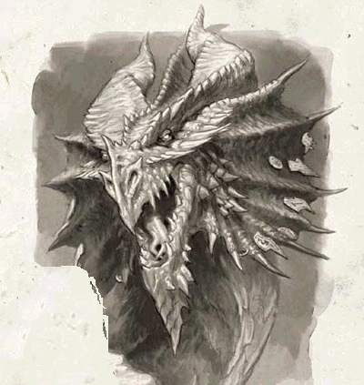SIZE: 30-40ft., 4-6 tons
ATTRIBUTES:
INT +3
WIL +3
PER +3
STR +10
DEX -2
CON +5
CHA -3
SPD -1

LEVEL: 10-20+
ATTACKS: Bite DR24; Claws, DR18; Tail DR14; Fiery Breath, DR4 per level total of 2 attacks per round
SPECIAL ABILITES: Breathe Fire 4 times per day, Cryptomancy, 4 modes at ability level, converse in 3 or more languages, flight. Immune to fire
ARMOR: Scaled Skin PR8
HP: 75
HABITAT: Wilderlands, abandoned ruins
COMMENTS: Crested Dragons are territorial by nature, and seldom venture beyond their chosen domains. Though few in number, these creatures are intensely jealous, and rivalries between various members of the species are not uncommon.

